

MANCETTER PARISH COUNCIL WOULD LIKE TO INVITE MANCETTER AND RIDGE LANE RESIDENTS TO A PARISH MEETING BEING HELD AT 7PM ON TUESDAY 23rd MAY 2023 IN THE SCHOOLROOM AT ST PETER’S CHURCH MANCETTER.

MEET LOCAL GROUPS AND ORGANISATIONS, POLICE, COUNCILLORS AND COUNTY HIGHWAYS TO TACKLE ISSUES WITHIN OUR COMMUNITY.

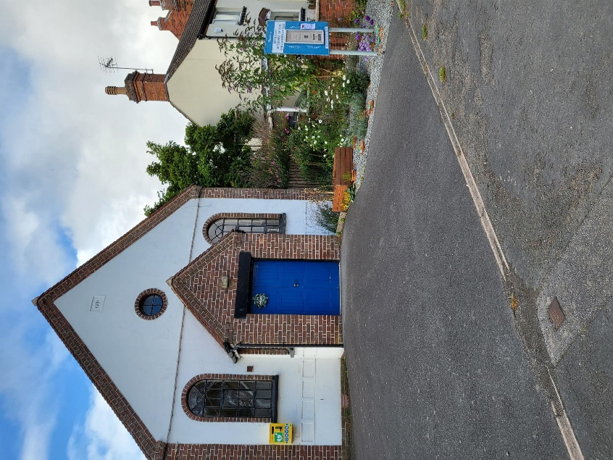

WE HOPE THAT YOU CAN JOIN US TO SHARE YOUR VIEWS AND SUGGEST WAYS THAT WE CAN MAKE OUR VILLAGES BETTER PLACES TO LIVE.